REST - Country Web Service
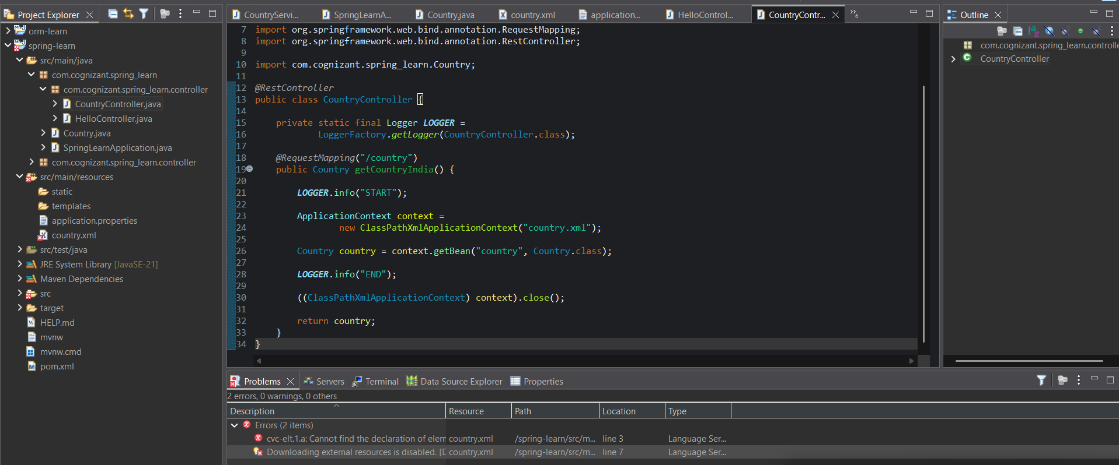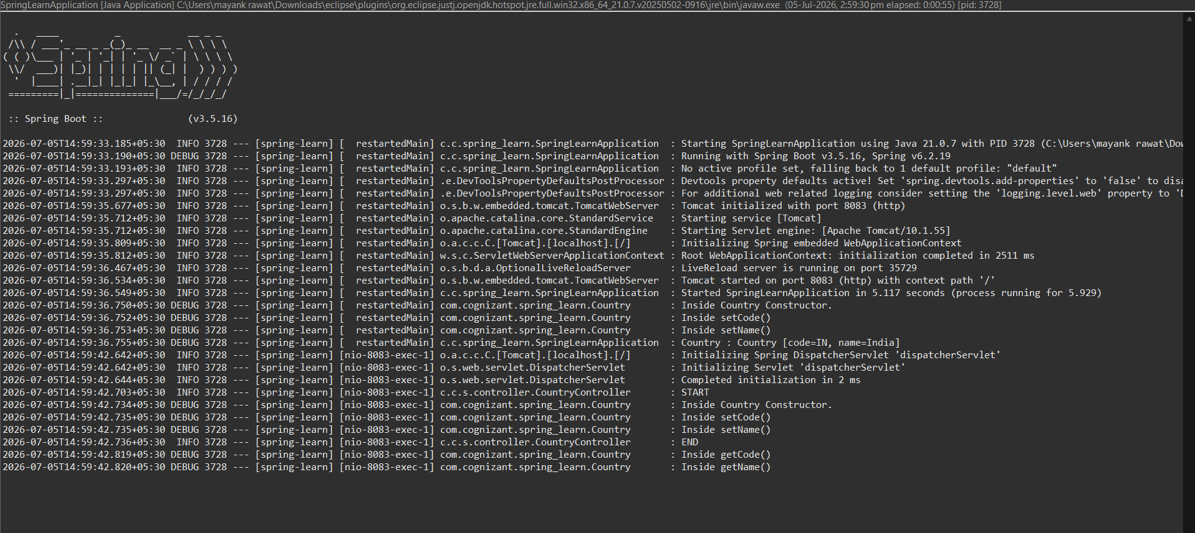
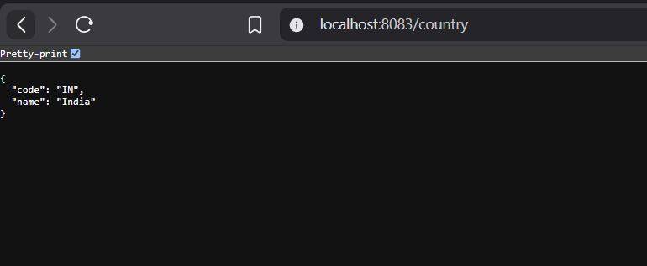

SpringLearnApplication.java
package com.cognizant.spring_learn;
import org.slf4j.Logger;
import org.slf4j.LoggerFactory;
import org.springframework.boot.SpringApplication;
import org.springframework.boot.autoconfigure.SpringBootApplication;
import org.springframework.context.ApplicationContext;
import org.springframework.context.support.ClassPathXmlApplicationContext;
REST - Country Web Service@SpringBootApplication
public class SpringLearnApplication {
private static final Logger LOGGER =
LoggerFactory.getLogger(SpringLearnApplication.class);
public static void main(String[] args) {
SpringApplication.run(SpringLearnApplication.class, args);
displayCountry();
}
public static void displayCountry() {
ApplicationContext context =
new ClassPathXmlApplicationContext("country.xml");
Country country =
context.getBean("country", Country.class);
LOGGER.debug("Country : {}", country.toString());
((ClassPathXmlApplicationContext) context).close();
}
}

Application.properties
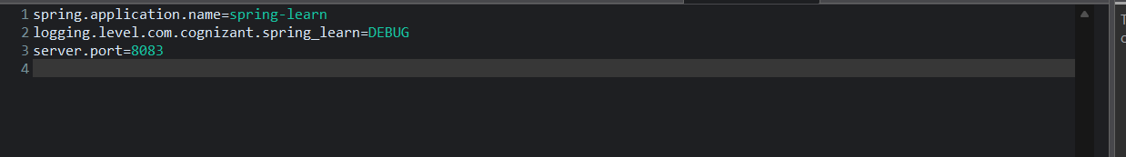

HelloController.java
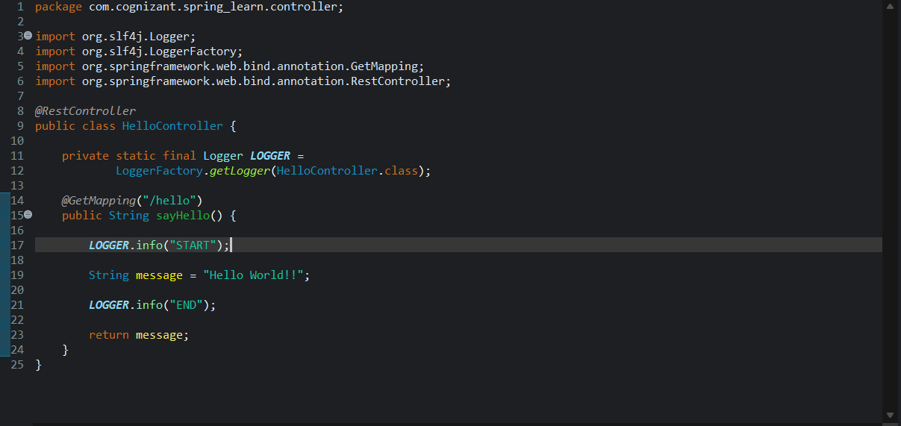

CountryController.java
package com.cognizant.spring_learn.controller;
import org.slf4j.Logger;
import org.slf4j.LoggerFactory;
import org.springframework.context.ApplicationContext;
import org.springframework.context.support.ClassPathXmlApplicationContext;
import org.springframework.web.bind.annotation.RequestMapping;
import org.springframework.web.bind.annotation.RestController;
import com.cognizant.spring_learn.Country;
@RestController
public class CountryController {
private static final Logger LOGGER =
LoggerFactory.getLogger(CountryController.class);
@RequestMapping("/country")
public Country getCountryIndia() {
LOGGER.info("START");
ApplicationContext context =
new ClassPathXmlApplicationContext("country.xml");
Country country = context.getBean("country", Country.class);
LOGGER.info("END");
((ClassPathXmlApplicationContext) context).close();
return country;
}
}

